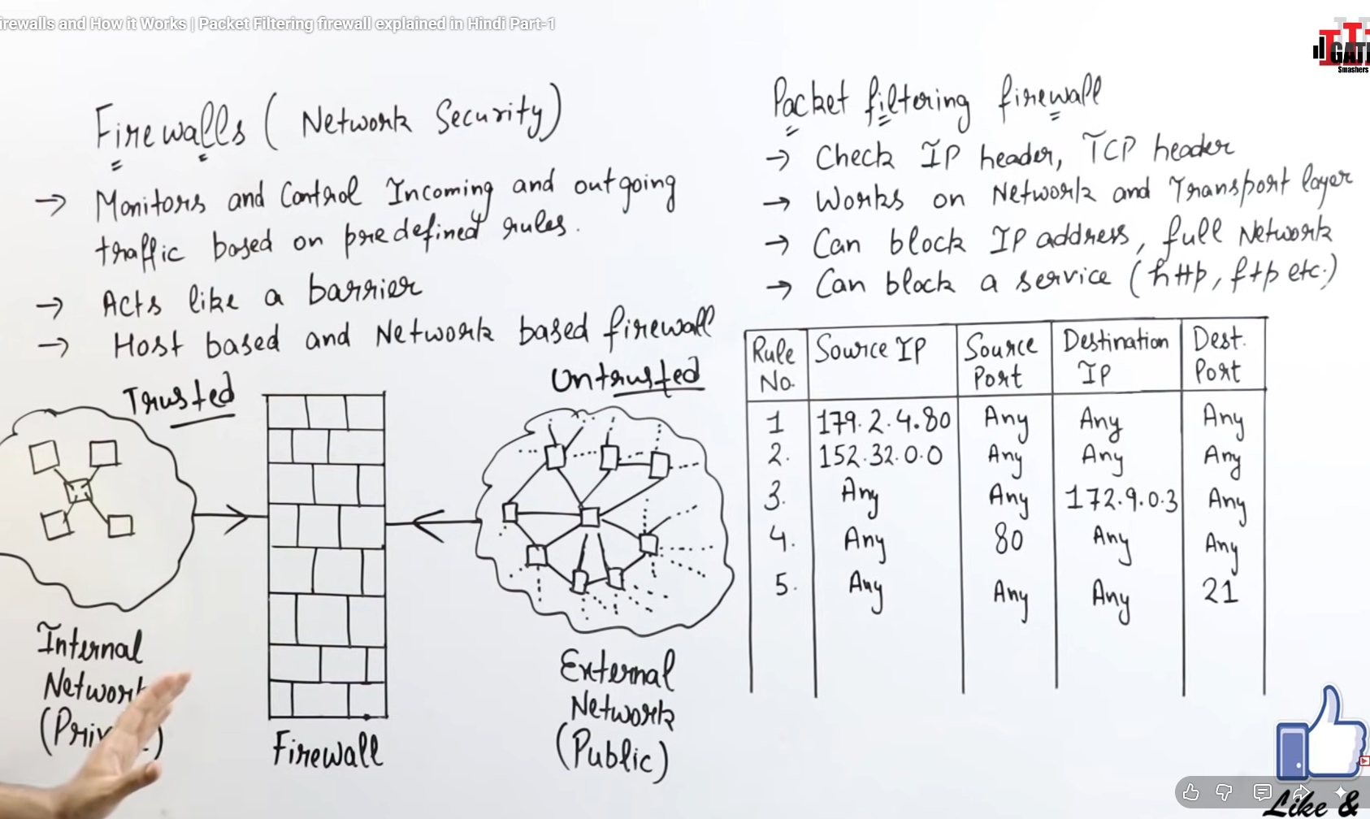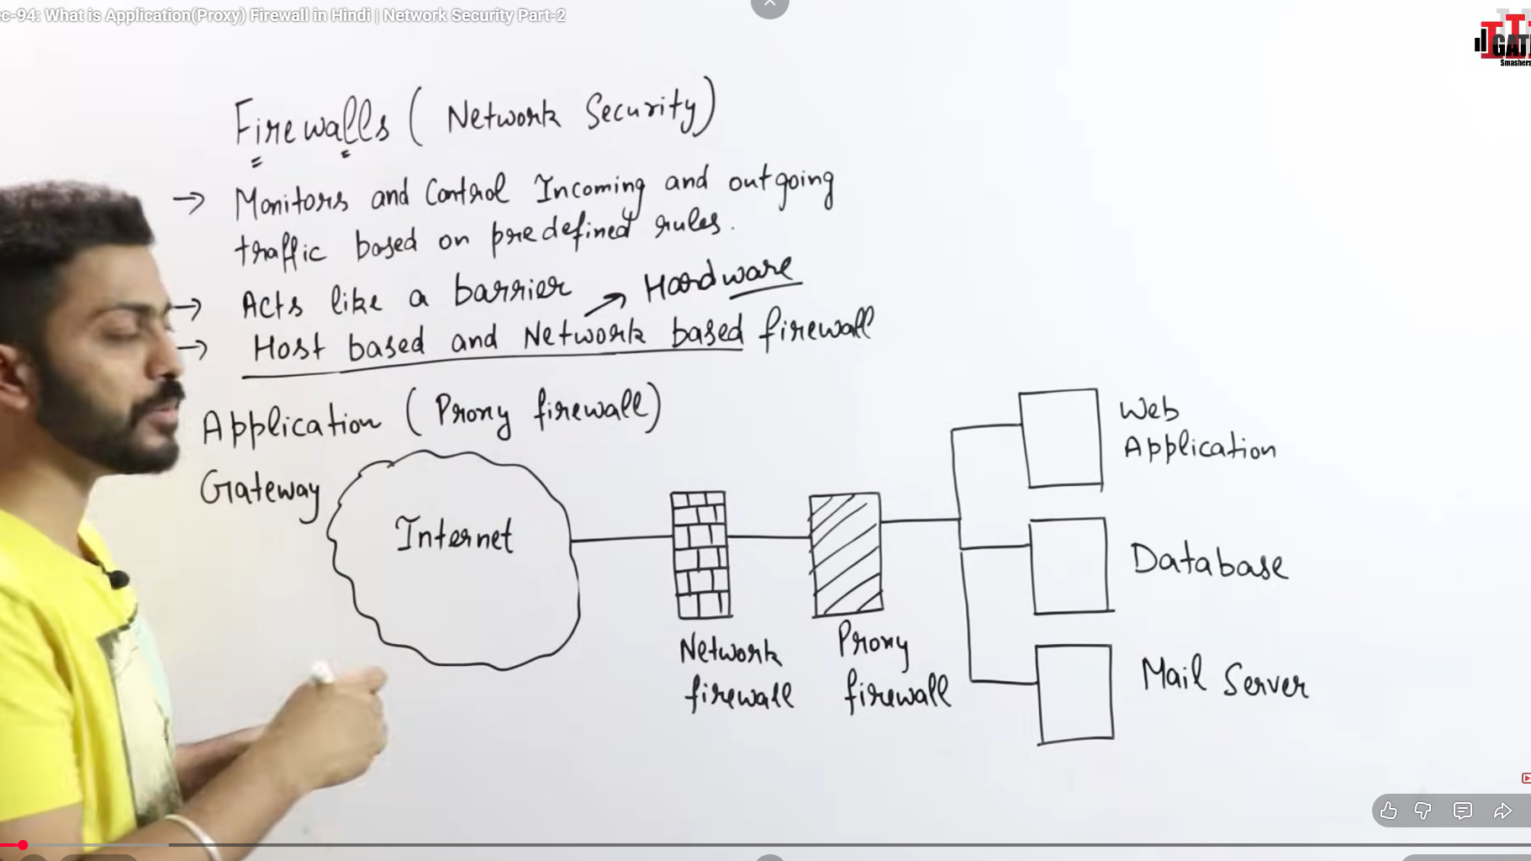
Proxy
A proxy is an intermediary server that sits between a client and another server.
Instead of communicating directly, requests pass through the proxy.
There are two main types:
- Forward Proxy → represents the client
- Reverse Proxy → represents the server

Forward Proxy
A forward proxy sits in front of clients.
Client → Forward Proxy → Internet/Server
The destination server sees the proxy’s IP, not the original client.

Common Uses
- Hiding client identity
- Access control
- Content filtering
- Bypassing geo restrictions
- Caching internet content

Example
In a company network:
Employee PC → Corporate Proxy → Google
The company proxy can:
- Block websites
- Log activity
- Cache responses
- Hide employee IPs

Real-world Examples
- VPN services
- Corporate internet proxies
- School/office internet filtering systems

Reverse Proxys
A reverse proxy sits in front of servers.
Client → Reverse Proxy → Backend Server
The client thinks it’s talking directly to the server.

Common Uses
- Load balancing
- SSL termination
- Security
- Caching
- Compression
- Hiding backend servers

Example
Browser → NGINX Reverse Proxy → App Servers
The reverse proxy may:
- Route traffic to multiple servers
- Handle HTTPS
- Protect backend servers
- Cache responses

Real-world Examples
- NGINX
- HAProxy
- Cloudflare
- Traefik

Key Difference
Feature | Forward Proxy | Reverse Proxy
Represents | Client | Server
Positioned in front of | Clients | Servers
Hides | Client identity | Server identity
Used by | Client/network admin | Website/backend owner
Main purpose | Control outgoing traffic | Manage incoming traffic

Easy Analogy

Forward Proxy
Like asking a friend to fetch something for you:
You → Friend → Store
The store sees your friend, not you.

Reverse Proxy
Like a receptionist in an office building:
Visitor → Receptionist → Employee
The receptionist decides where requests go.

In Modern Web Architecture
A typical production system often uses reverse proxies:
User
↓
NGINX / Cloudflare
↓
Application Server
↓
Database
Benefits:
- Better performance
- Improved security
- Scalability
- SSL handling
- Load balancing

Quick Summary
- Forward proxy protects/manages clients
- Reverse proxy protects/manages servers
A simple memory trick:
Forward = forward from the client
Reverse = reverse toward the server

